**Practical-2**

**Aim: Blog creation and content writing, posting and google analytics.**

**Prerequisites Analysis**

**What is a Blog?**

A blog (short for weblog) is a regularly updated website or web page that presents information in a conversational style, typically run by an individual or small group, focusing on a specific subject or serving as a personal journal.

**Decision Factors for Creating a Blog**

1. Professional Development:
   * Establishing expertise in AI and healthcare technology
   * Building a professional portfolio
   * Networking with industry professionals
2. Market Analysis:
   * Growing interest in AI healthcare applications
   * Limited technical expertise among healthcare professionals
   * Need for clear, accessible content explaining complex technologies
3. Benefits:
   * Knowledge sharing and community building
   * Professional visibility
   * Potential consulting opportunities
   * Portfolio development for tech roles
4. Personal Motivation:
   * Passion for healthcare technology
   * Background in IT with healthcare industry exposure
   * Desire to bridge the gap between technical and medical professionals

**Task 1: Topic Selection and Analysis**

Selected Topic: "AI in Healthcare: Breaking Down Complex Technologies"

**Task 2: Platform Selection**

Selected Platform: WordPress

**Task 3: Content Writing Guidelines**

**Content Gathering Techniques:**

1. Primary Sources:
   * Academic journals (PubMed, Nature)
   * Medical technology conferences
   * Industry whitepapers
   * Expert interviews
2. Secondary Sources:
   * Healthcare technology news websites
   * Industry reports
   * Case studies
   * Professional forums

**Content Creation Framework:**

1. Research Phase:
   * Topic validation through keyword research
   * Current trends analysis
   * Expert opinion gathering
   * Statistical data collection
2. Writing Structure:
   * Clear introduction with problem statement
   * Technical explanation in simple terms
   * Real-world applications
   * Future implications
   * Call to action or discussion prompt
3. Content Calendar: Week 1: "Introduction to AI in Medical Imaging" Week 2: "Machine Learning for Early Disease Detection" Week 3: "Implementing AI in Clinical Workflows" Week 4: "Data Privacy Challenges in Healthcare AI"

**Task 4: Google Analytics Implementation**

**Setup Process:**

1. Google Analytics Account Creation:
   * Create Google Analytics 4 property
   * Configure data streams
   * Set up enhanced measurement
2. WordPress Integration:
   * Install MonsterInsights plugin
   * Configure authentication
   * Set up tracking parameters

**Key Metrics to Track:**

1. Audience Metrics:
   * User demographics
   * Professional backgrounds
   * Geographic distribution
   * Device preferences
2. Behavior Metrics:
   * Popular content
   * Time on page
   * Bounce rate
   * User flow
3. Conversion Metrics:
   * Newsletter signups
   * Resource downloads
   * Comment engagement
   * Return visitor rate

**Sample Analytics Dashboard Configuration:**

1. Overview Dashboard:
   * Daily/weekly visitor trends
   * Top performing articles
   * Traffic sources
   * User engagement metrics
2. Content Performance Dashboard:
   * Article performance comparison
   * Topic category analysis
   * Reader retention metrics
   * Social sharing statistics

**Implementation Screenshots**

1. WordPress setup process

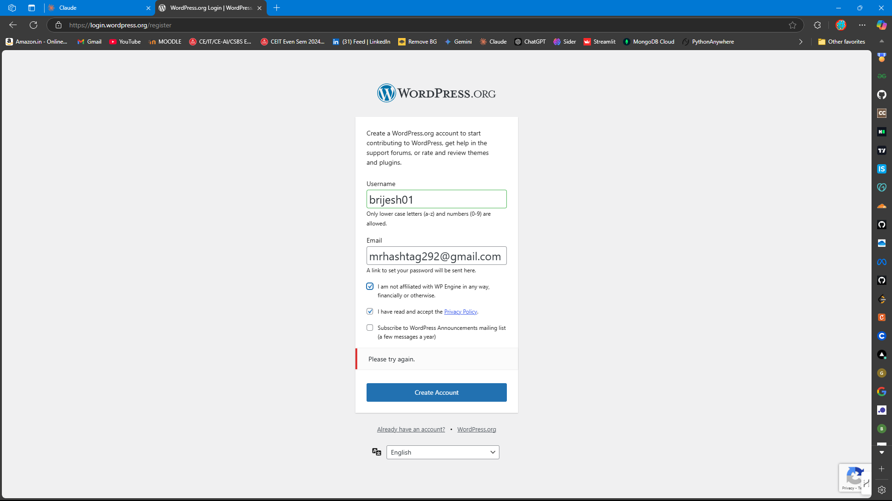

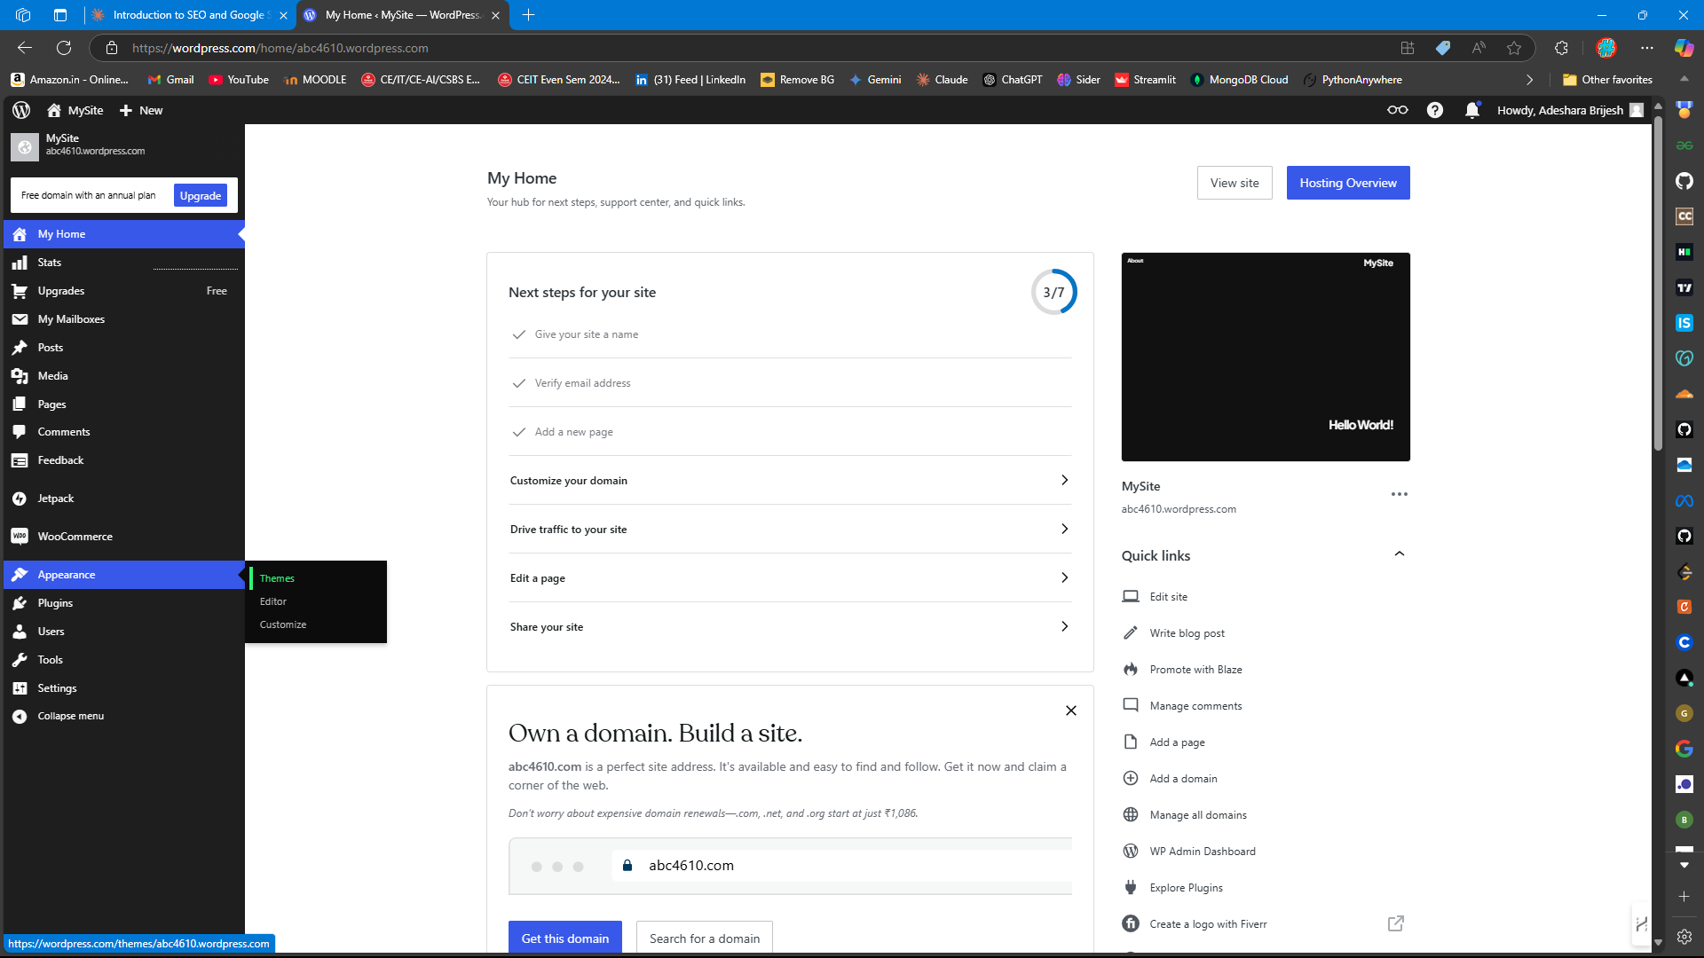

1. Theme customization

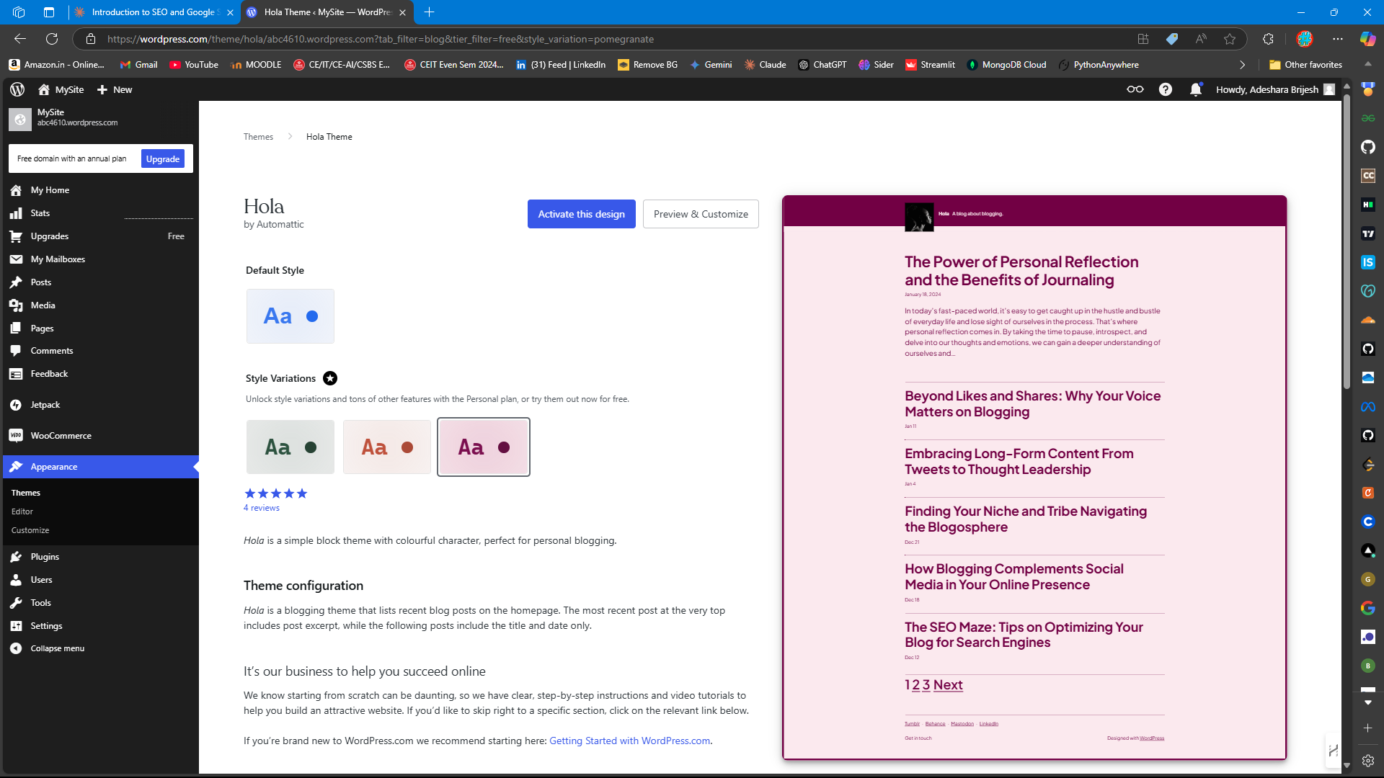

1. MonsterInsights configuration

1. Google Analytics dashboard
2. Sample blog posts
3. Analytics reports